U9 Spy USB Stick
User Manual

Contents
Package Contents 2
Before You Start 2
Overview 3
Controls 3
SD Card Slot (TF) 3
USB: Syncing and Charging 3
Power / Audio Capture 4
Turn On 4
Turn Off 4
Audio Capture 4
Photo / Video 4
Camera Mode 4
Video Mode 4
Motion Detection 4
Timestamp Edit 5

Package Contents
- Spy Black USB Stick

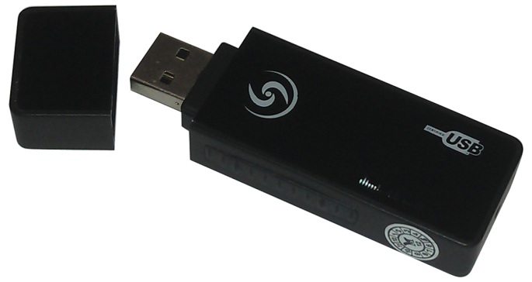

Before You Start
Make sure you have charged the device for 8 or more hours prior to full use.
It is recommended that you charge for 24 hours; however we know this is not always possible.
Turn over for charging instructions…

Overview
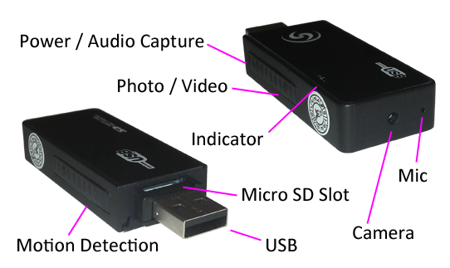
Figure 1
Figure 1 shows the controls that the USB stick uses.

Controls

SD Card Slot (TF)
You are able insert a Micro SD card (TF) up to 32GB into this USB stick.
When holding the USB stick with the Micro SD slot on top, make sure the Micro SD card is facing up so the contact points are facing down (Figure 2).
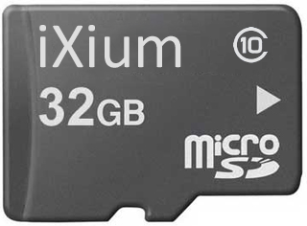
Figure 2

USB: Syncing and Charging
Plug the memory stick camera into a USB port on your computer; this enables you to charge the battery and transfer the files that are saved on the Micro SD Card.

Power / Audio Capture

Turn On
Press and hold the power/audio button until you can see the blue and red indicators light up and it starts to vibrate (this should only take 2 or 3 seconds). When the USB stick is ready the blue indicator will go out.

Turn Off
Press and hold the power/audio Capture button, the blue indicator will flash and vibrate and then turn off (this should only take 2 or 3 seconds).

Audio Capture
Quickly press the power/audio Capture button and the indicator will flash blue, vibrate and then go out. This is now recording audio only.
To stop recording audio quickly press the power/audio Capture button again and the USB stick will vibrate and the red indicator will light up. You can turn the USB stick off from here or carry on to use one of the other functions.

Photo / Video
This button enables you to switch between the camera and standard video features depending on what you need.

Camera Mode
Turn the USB Stick on. Once the indicator has turned red then all you need to do is point the USB Stick in the direction you wish to take a picture and quickly press the photo/video button. The blue indicator will light up and vibrate and the red one will go out momentarily and come back when ready to take the next picture.
When you are done taking pictures you can turn the USB Stick off or use one of the other functions.

Video Mode
Turn the USB Stick on. Once the indicator has turned red press and hold the photo/video button and the red indicator will start flashing and vibrates twice (this should only take 2 or 3 seconds) and then go out. It is now recording video. The maximum file size for each recording is 15 minutes.
When you are done taking video quickly press the photo/video button and the red indicator will come back on with a vibration. You can turn the USB Stick off or use one of the other functions.

Motion Detection
Turn the USB Stick on. Quickly press the motion detection button and the blue and red indicators will flash, go out and vibrate 3 times; place where you want it to record. It will record in short chunks of video. If there is still motion when one section ends then it will start a new section.
To stop the USB Stick recording, quickly press the motion detection button, the red indicator will come back on with a vibration which means it has stopped recording.
You can turn the USB stick off from here or carry on to use one of the other functions.

Timestamp Edit
You may need to update the internal clock for the timestamp shown in images and videos.
To do this, you will need to create a Text file with the date and time.
- Plug the camera into your computer by using a USB cable.
- It will appear as a Removable Disk.
- Open the Removable Disk; you might have a folder called DCIM and a text file called “time” already there.
- If you already have a file called “time” then move onto Step 7.
- Right click in the white space and a menu will appear (Figure 3), move down to “New” and select “Text Document”.

Figure 3
- A new Text document will appear (Figure 4) and give you the option to name it, call it “time”.
Figure 4
- Open this time file and write the date and time in the following method:
2010.01.26 10.10.59 Y (this is example only, use the correct date/time)
2010.01.26 10.10.59 N (Y to display timestamp, N to not display timestamp)
- Save and close the file.
- Unplug the camera from the computer and turn it on. The time is now updated.
- Plug the USB Stick back into your computer and delete the time file if still there.

(next page)

